H.T No
Regulations:
A18

Sreenidhi Institute of Science and Technology
(An Autonomous Institution)
Code No: 7AC07 Date: 24-Mar-2021 (FN)

B.Tech III-Year I- Semester External Examination, March/April - 2021 (Regular)
CONTROL SYSTEMS (ECE)

Time: 3 Hours Max.Marks:70

Note: a) No additional answer sheets will be provided.
b) All sub-parts of a question must be answered at one place only, otherwise it will not be valued.
c) Missing data can be assumed suitably.

ANSWER ANY 5 OUT OF 8 QUESTIONS. EACH QUESTION CARRIES 14 MARKS.

Bloom's Cognitive Levels of Learning (BCLL)

Remember | L1 | Apply | L3 | Evaluate | L5
Understand | L2 | Analyze | L4 | Create | L6

 |  |  | BCLL | CO(s) | Marks
1. | a) | What is Control System? Distinguish between open loop and closed loop control systems with examples. | L2 | CO1 | [7M]
 | b) | Determine the closed loop transfer function C(S)/R(S) of the system whose block diagram is shown in below figure.  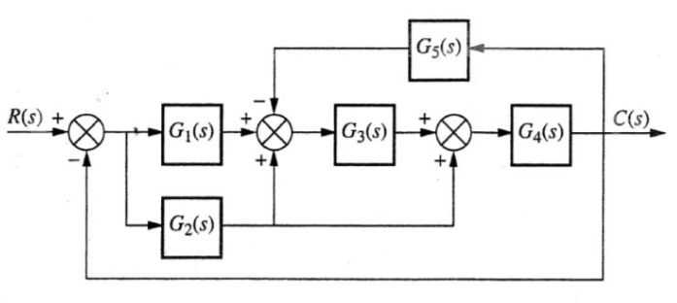 | L3 | CO1 | [7M]
2. | a) | Define the following terms  - Delay time  - Rise time  - Peak time  - Peak Overshoot  - Settling time.  Also express them mathematically. | L1 | CO2 | [7M]
 | b) | The open loop transfer function of a unity feedback control system is  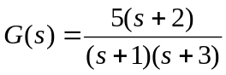  Using the generalized error series, determine the error signal and steady state error of the system when it is excited by  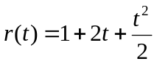 | L3 | CO2 | [7M]
3. | a) | The characteristic equation for certain feedback control systems is given below.  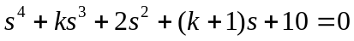  (i) Determine the range of values of ‘k’ for the system to be stable,  (ii) Can the system be marginally stable? If so, find the required value of ‘k’ and the frequency of sustained oscillations. | L3 | CO3 | [7M]
 | b) | What is Root Locus? State the different rules of construction of Root Loci. | L2 | CO3 | [7M]
4. | a) | Define the following terms.  - Resonant frequency  - Bandwidth  - Cut-off rate  - Gain Margin  - Gain crossover frequency | L1 | CO4 | [7M]
 | b) | Sketch the Bode plot for following transfer function and determine the gain margin and phase margin of the system. Also comment on the stability of the system.  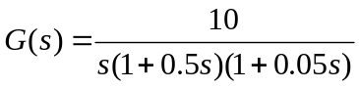 | L3 | CO4 | [7M]
5. | a) | Sketch polar plot of the transfer function  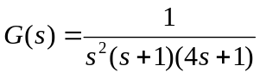  Determine whether these plots cross real axis. If so, determine the frequency at which the plot cross the real axis and the corresponding magnitude. | L3 | CO5 | [7M]
 | b) | Derive expression for transfer function of  i) Lead Compensator. ii) Lag Compensator. | L3 | CO5 | [7M]
6. | a) | Define the following terms.  - State  - State Variable  - State Vector  - State Space | L2 | CO6 | [7M]
 | b) | Derive the transfer function corresponding to the following state model.  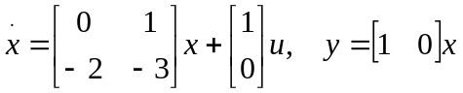 | L3 | CO6 | [7M]
7. | a) | Explain the basic elements used for modeling mechanical rotational system. | L2 | CO1 | [5M]
 | b) | Derive expressions for Static error constants. | L3 | CO2 | [5M]
 | c) | Explain procedure to determine angle of arrival from poles and zeros to complex zeros. | L2 | CO3 | [4M]
8. | a) | State the advantages and limitations of frequency domain approach. | L1 | CO4 | [5M]
 | b) | Explain Nyquist stability Criterion. | L2 | CO5 | [5M]
 | c) | Derive expression for the solution of homogeneous state equation. | L3 | CO6 | [4M]

-- 00 -- 00 –

